The Conspirator in Question | Reasons why the Conspirator conspired to kill Julius Caesar. (use direct quotes from source) | Is this information reliable? Explain why/why not. | Do you think that the conspirator was justified in assassinating Julius Caesar? Explain your answer.
Brutus
Cassius |  |  | 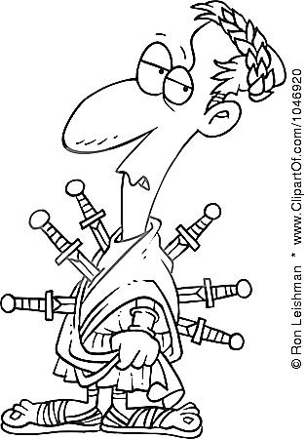
Julius Caesar’s Conspirator Inquiry “Information” Chart
Julius Caesar’s Conspirator Inquiry “Information” Chart

The Conspirator in Question | Reasons why the Conspirator conspired to kill Julius Caesar. (use direct quotes from source) | Is this information reliable? Explain why/why not. | Do you think that the conspirator was justified in assassinating Julius Caesar?  Explain your answer.
Cinna
Casca
Julius Caesar’s Conspirator Inquiry “Information” Chart

The Conspirator in Question | Reasons why the Conspirator conspired to kill Julius Caesar. (use direct quotes from source) | Is this information reliable? Explain why/why not. | Do you think that the conspirator was justified in assassinating Julius Caesar?  Explain your answer.
Metellus
Decius
Julius Caesar’s Conspirator Inquiry “Information” Chart

The Conspirator in Question | Reasons why the Conspirator conspired to kill Julius Caesar.(use direct quotes from source) | Is this information reliable? Explain why/why not. | Do you think that the conspirator was justified in assassinating Julius Caesar?  Explain your answer.
Trebonius
Ligarius

